**Level Medium:**

**Q1:**A batsman is out for 68 runs which raise his batting average for the season from 32 to 36. How many runs would he have had to have scored to raise his average for the season to 39?  
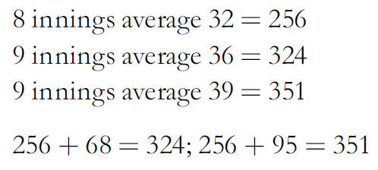  
Ans: 95  
  
**Q2:**

At a recent small town election for mayor a total of 963 votes were cast for the four candidates, the winner exceeding his opponents by 53, 79, and 105 votes, respectively. How many votes were cast for each candidate?

Solution:  
The number of votes the winning candidate received was (963 + 53 + 79 + 105) ÷ 4 = 300.

The second received 300 - 53 = 247.

The third received 300 - 79 = 221, and

The fourth received 300 - 105 = 195.  
  
**Q3:**How many positive integers between 0 to 1000 are not exactly divisible by 3?  
  
Ans: 666

The integers between 0 and 1000 that are exactly divisible by 3 are 3, 6, 9, 12, 15, 18, ... You can see that there are 999 ÷ 3 = 333 integers between 0 and 1000 that are exactly divisible by 3. The integers between 0 and 1000 are 1, 2, 3, ..., 999. This is a total of 999 - 1 + 1 = 999 integers. Thus 999 - 333 = 666.  
  
**Q4:**

A company produces 864 white, black and red motor vehicles per week in the ratio 1 : 5 : 3. How many black cars does the company per week?

Ans: 480

Add 1 + 5 + 3 = 9.

864÷ 9 = 96

96 x 5 = 480.  
  
**Q5:**At the end of the day one market shall had 16 apples and 48oranges left. Another market stall had 36 apples and 24 oranges left. What is the difference between the percentages of apples left in the two market stalls?  
  
Ans: 35%

First stall out of 64 = 25%.

Second stall 36 out of 60 = 60%.

Difference in percentages = 35%.  
  
**Q6:**

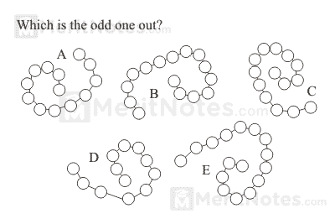  
Ans: D

It goes anti clockwise from outer to inner, the others going clockwise from outer to inner.  
  
**Q7:**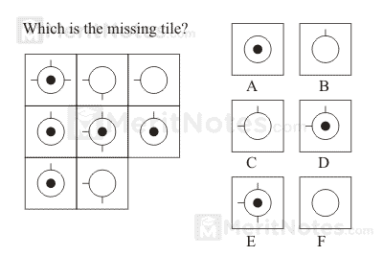  
Ans: F

Only symbols which are common to the first two squares in each horizontal and vertical line are carried forward to the final square.  
  
**Q8:  
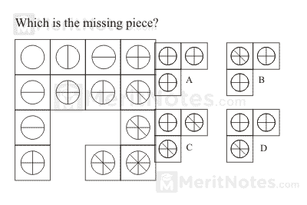**

Ans: D

Horizontally and vertically the sequence runs â€“ add one lines, add one line etc.  
  
**Q9:**

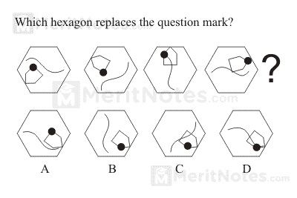

Ans:C

Swirl moves 120° clockwise; black dot moves corner to corner of the pentagon clockwise; pentagon moves 60° clockwise.  
  
Q10:

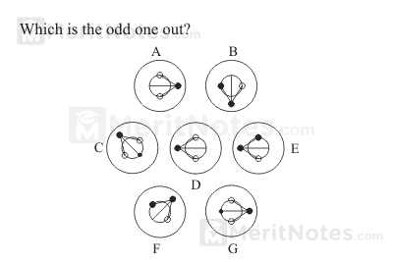

Ans: F

A is the same as D

B is the same as E

C is the same as G  
  
Q11:

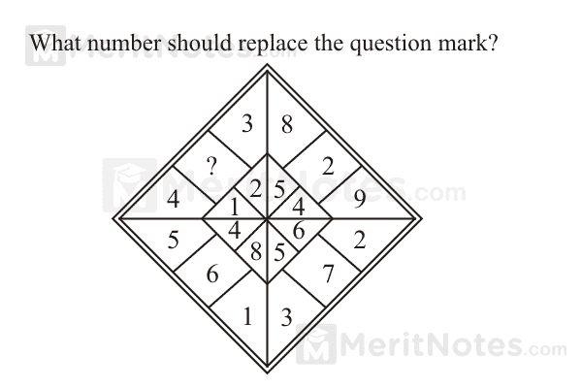

Ans: 10

There are 8 groups of three numbers round the diamond totaling 15; 10 + 3 + 2 = 15.

8 + 2 + 5 = 15 etc.  
  
Q12:

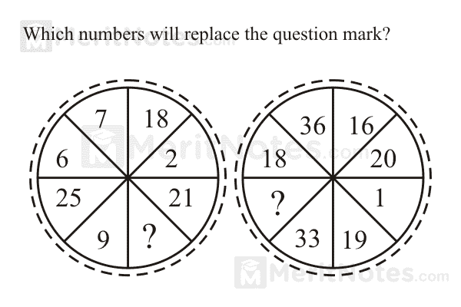

Ans: 20 & 37 or 3

Opposite segments add to 27.

Opposite segments are subtracted = 17.  
  
Q13:

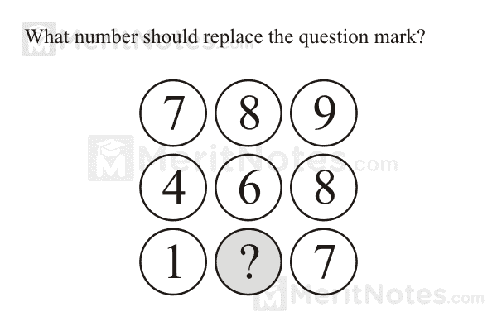

Ans: 4

Looking across and down the middle number is the sum of the two other numbers above and below, divided by 2.  
  
Q14:

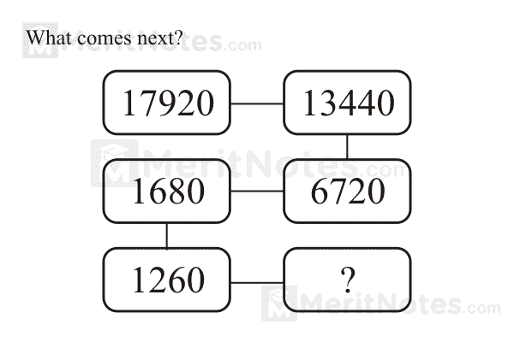

Ans: 630

Multiply by three quarters, one half, one quarter and repeat.  
  
Q15:

In 15 year's time the combined age of my four brothers will be 107. What will it be in six years time?  
  
Ans: 71

Combined age in 15 years = 107.

4 x 15 = 60, therefore combined age now is 107 -60 = 47.

In 6 year's time, therefore, combined age will be 47 + 24 (4 x 6) = 71.  
  
Q16:

A snail is climbing out of a well that is 10 feet deep. Every hour the snail climbs up 3 feet and slides back down 2 feet. How many hours will it take for the snail to escape from the well?  
  
Ans: 8 hours

After 1 hour it has climbed one foot. After 7 hours it has climbed 7 feet. In the eight hour it climbs the remaining 3 feet and is at the top, so does not slide back.  
  
Q17:

There are two brothers and two sisters. In 10 years they will total 100 in their ages. How much will the total be in 7 years?

Ans: 88 years  
  
Q18:

Midway through his round a golfer hits a 203 yard drive which brings his average length per drive for the round up to now from 176 to 179 yards. How far would he have had to hit the drive to bring his average length of drive up from 176 to 181 yards?  
  
Ans: 221 yards

8 holes average 176 = 1,408 yards

9 holes average 179 = 1,611 yards

9 holes average 181 = 1,629 yards

1,408 - 1,629 = 221 yards.  
  
**Q19:**

I am four times as old as my son. In 20 year's time, I shall be twice as old as him. How old are we today?

Ans: I am 40; my son is 10.

In 20 year's time, I shall be 60, and he will be 30.  
  
**Q20:**

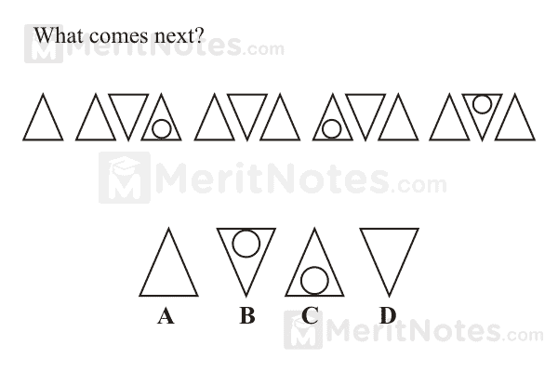  
Ans: A

Every third figure is upturned and every fourth figure has a dot.

**Q21:**

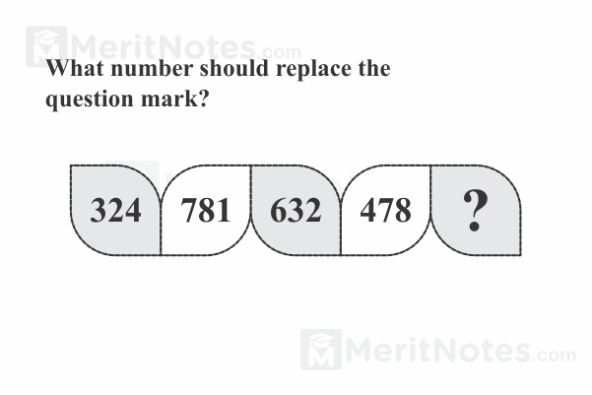

Ans: 163.

The digits 32478116 are being repeated over and over in groups of three digits.

**Q22:**

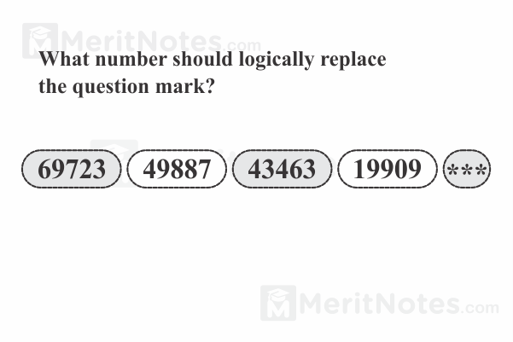

Ans: 17271

Each term in the series is the first two digits of the previous term times the last three digits of the previous term.

**Q23:**

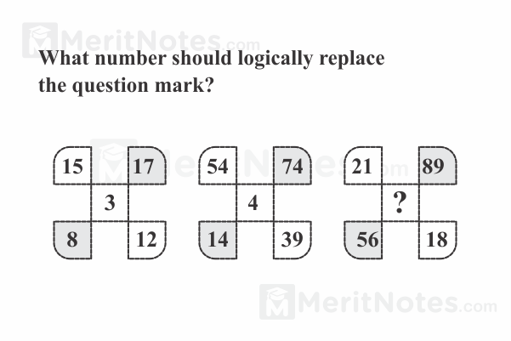

Ans: 11

The center number is the difference between the upper right number and the lower left number divided by the difference between the upper left number and the lower right number. 11 = (89 â€“ 56) ÷ (21 â€“ 18).

**Q24:**

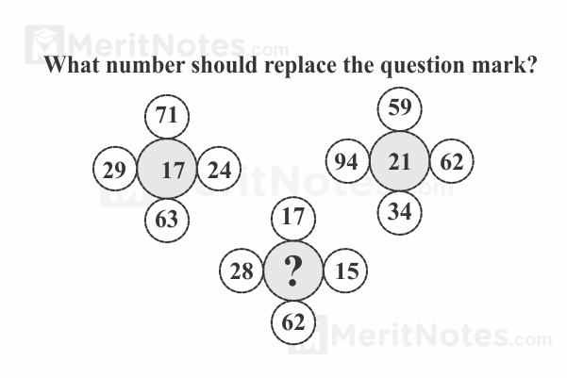

Ans: 16

The center number is the sum of the digits above and below it, and also the digits left and right of it. 16 = 1 +7 +6 +2 = 2 +8 +1 + 5.

**Q25:**

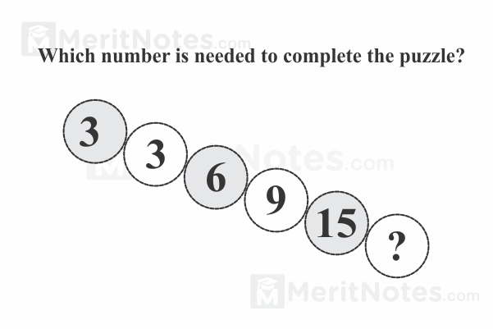

Ans: 24

Each number equals the sum of the two numbers above it.

**Q26:**

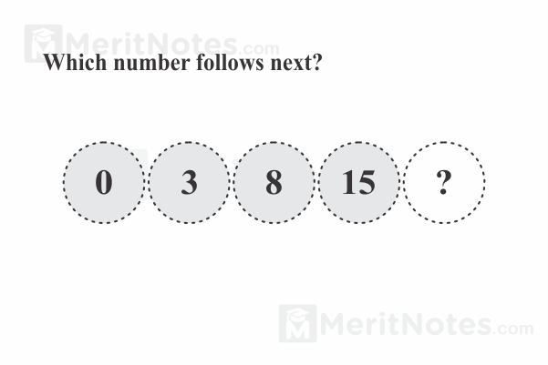

Ans: 24

Square the numbers 1, 2, 3, 4 and 5 and subtract 1.

**Q27:**

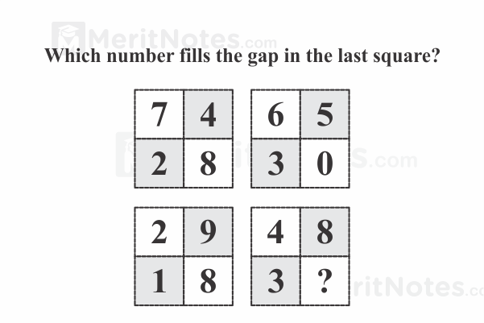

Ans: 2

For each circle multiply the top two numbers together to give a 2 digit value, written in the bottom segments

**Q28:**

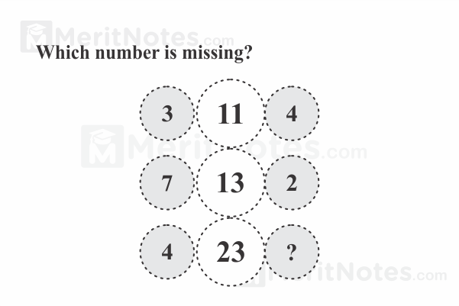

Ans: 6

The centre figure is the product of the left and right numbers, minus 1.

**Q29:**

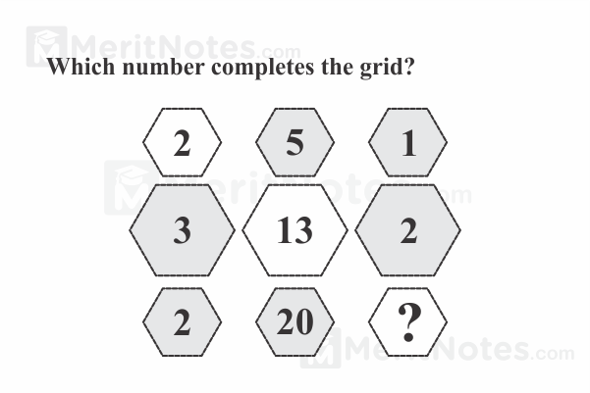

Ans: 4

Working in rows, the central value equals the sum of the squares of the left and right hand numbers.

**Q30:**

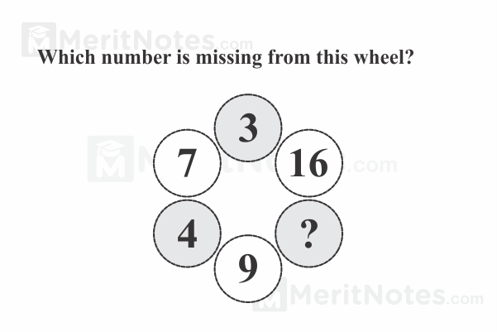

Ans: 49

Square the values in the segments on the left half, and put the results in the opposite segment on the right.

**Q31:**

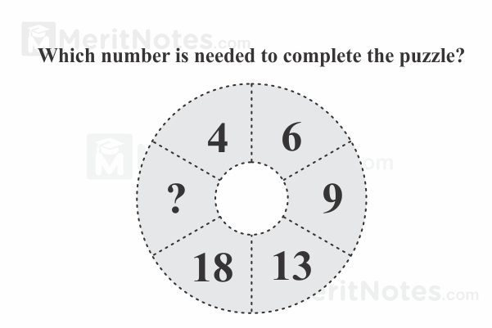

Ans: 24

Working clockwise, numbers increase by 2, 3, 4,5 and 6.

**Q32:**

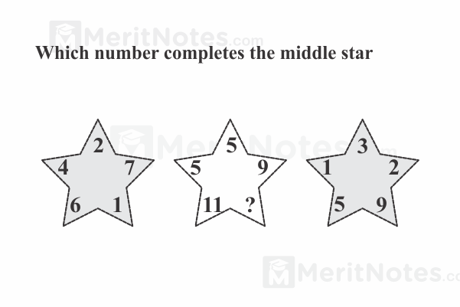

Ans: 10

The values of the points of the central star equal the sums of the values of the corresponding points of the left and right hand stars.

**Q33:**

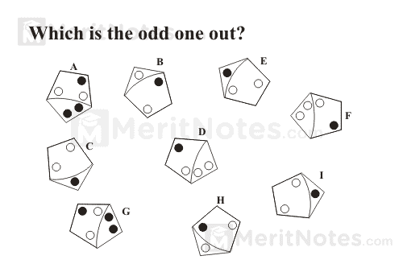

Ans: 152

As you move clockwise multiply the previous number by 2 and add 2, 3, 4, 5 and 6.

**Q34:**

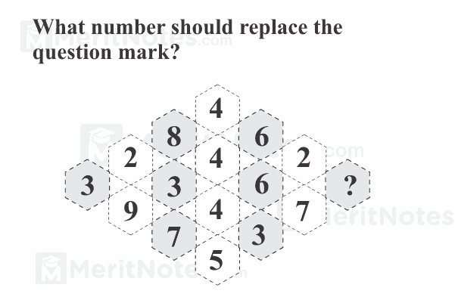

Ans: 5

Look at diagonal lines from bottom right hand corner to top.

The bottom and third digits multiplied together produce the number formed by the second and top digits.

So 5 x 7 = 35.

Similarly 3 x 8 = 24, 9 x 4 = 36 and 7 x 6 = 42.

**Q35:**

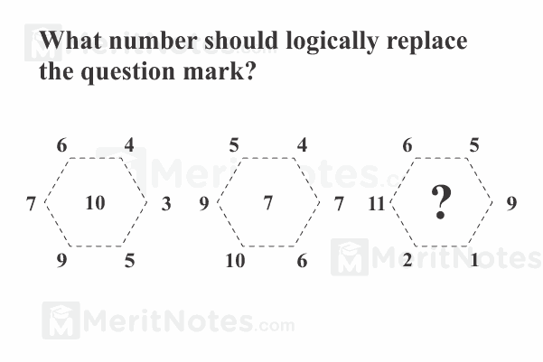

Ans: 4.

The center number is the difference between the sum of the left three numbers and the sum of the right three numbers 4 = (6 + 11 + 2) - (5 + 9 + 1).

**Q36:**

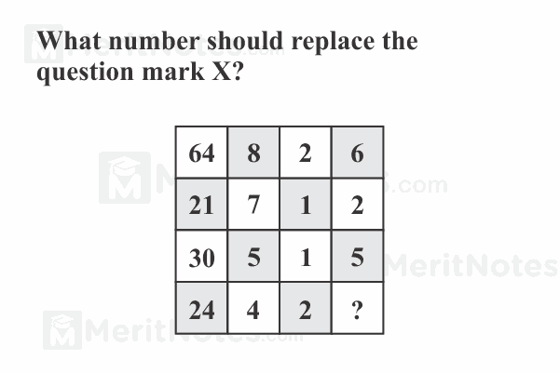

Ans: 4

64 ÷ 8 = 8 - 2 = 6

21 ÷ 7 = 3 - 1 = 2

30 ÷ 5 = 6 - 1 = 5

24 ÷ 4 = 6 - 2 = 4

**Q37:**

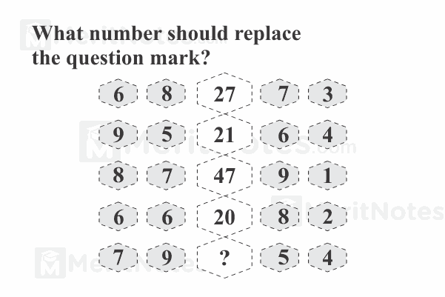

Ans: 43

( 7 x 9 ) - ( 5 x 4 )

63 - 20

43

**Q38:**

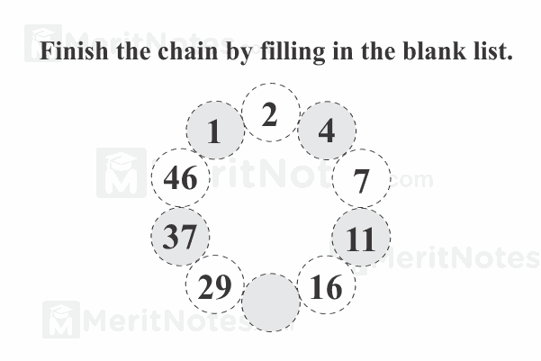

Ans: 22

Going clockwise, add 1, then 2, then 3 etc.

**Q39:**

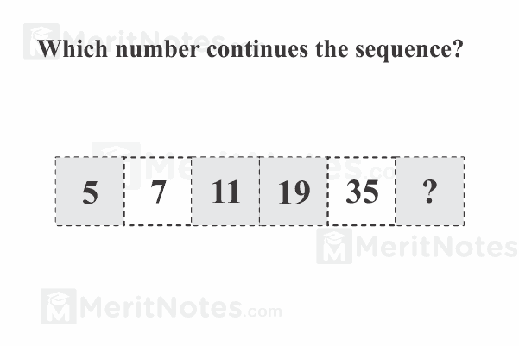

Ans: 67

As numbers go down multiply by 2 and subtract 3.

**Q40:**

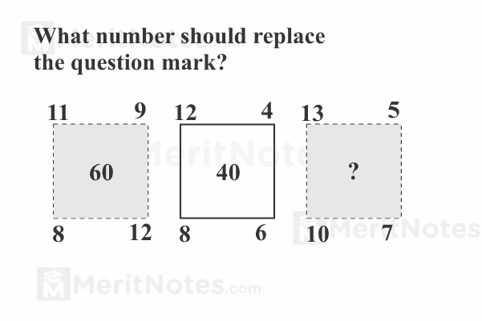

Ans: 41

The center number is the difference between the products of the two diagonals. 41 = (13 x 7) - (10 x 5).

**Q41:**

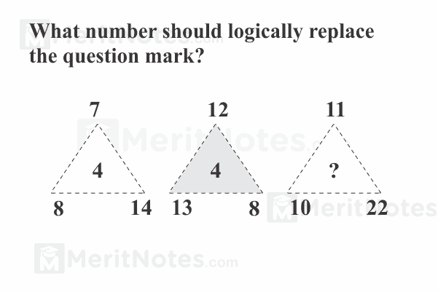

Ans: 5.

The middle number is the product of the top and lower left number divided by the lower right number. 5 = 11 x 10 ÷ 22.

**Q42:**

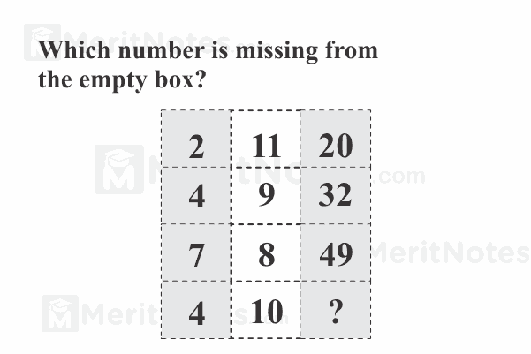

Ans: 36

In rows, multiply the left and centre numbers then subtract the smaller of the numbers to give the right hand value.

**Q43:**

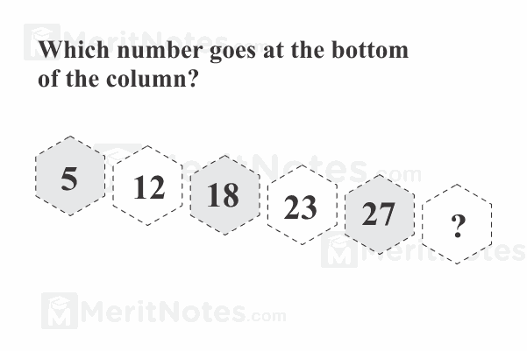

Ans: 30

Numbers increase by 7, then 6, 5, 4 and 3.

**Q44:**

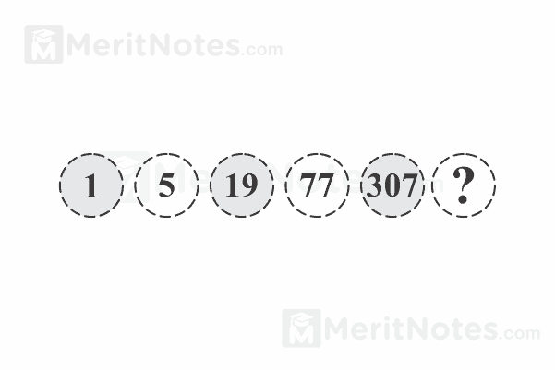

Ans: 1229

The sequence runs x 4 +1 and x 4 - 1 alternately.

**Q45:**

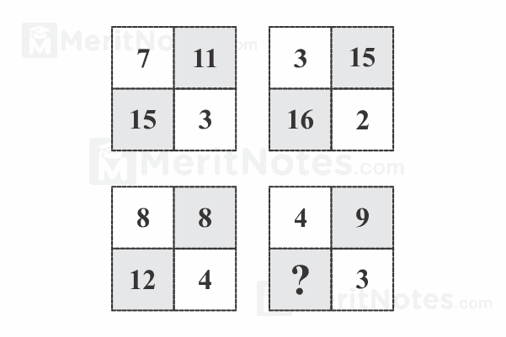

Ans: 10

In each circle, add the top 2 numbers and subtract the lower right number to give the lower left number.

**Q46:**

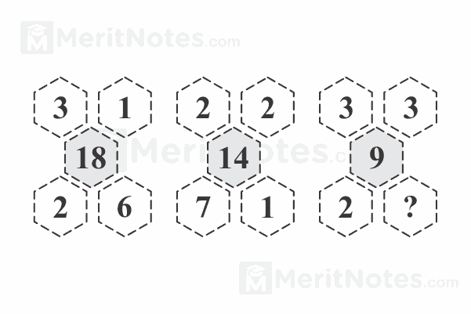

Ans: 1

Multiply the outer 4 numbers together and divide by 2 to give the central figure.

**Q47:**

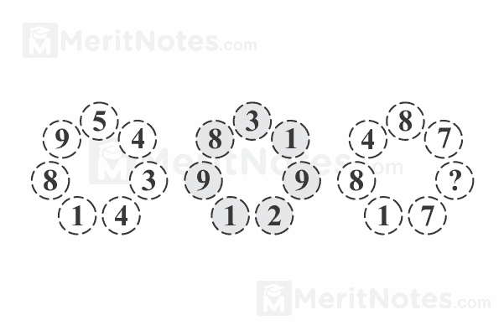

Ans: 1

Reading clockwise

89 + 54 = 143

98 + 31 = 129

84 + 87 = 171

**Q48:**

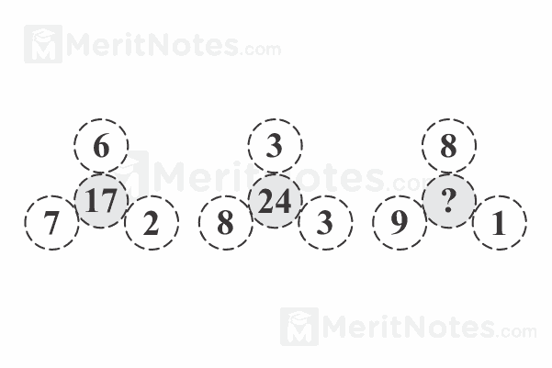

Ans: 6

The number in the first triangle is arrived at by adding the numbers at the top. ie 6 + 3 + 8 = 17.

Similarly, 7 + 8 + 9 = 24, and

2 + 3 +1 = 6

**Q49:**

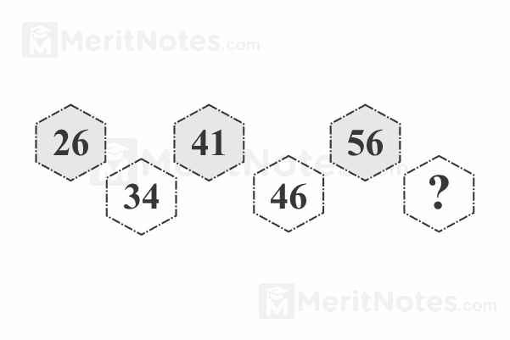

Ans: 67

Each number is obtained by adding together the digits of the previous number to the previous number. 67 = 56 + 5+ 6.

**Q50:**

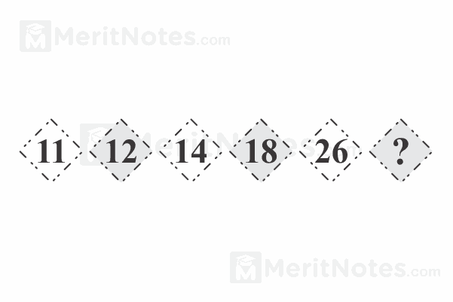

Ans: 42

As you go down, double the previous number and subtract 10.

**Q51:**

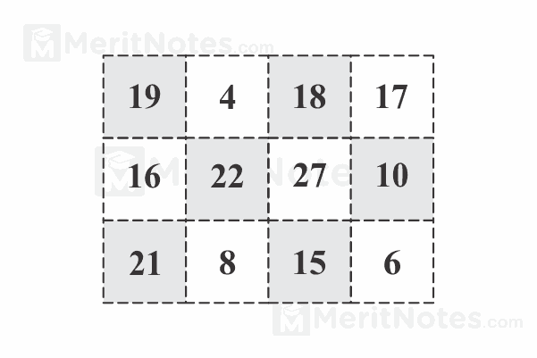

Ans: 24

27 + 21 = 48;

4 x 6 = 24;

48 - 24 = 24.

**Q53:**

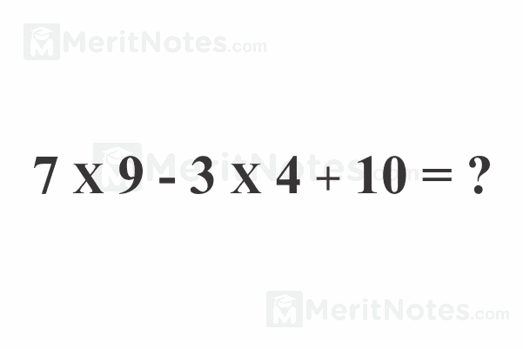

Ans: 61

(7 x 9) - (3 x 4) + 10 = 61.

**Q54:**

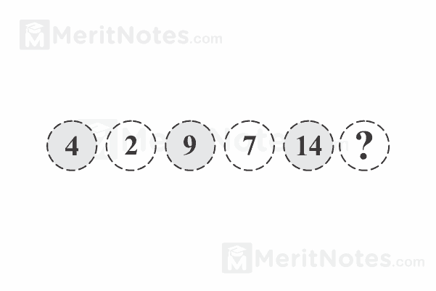

Ans: 12

Starting from the top, subtract then add 7 and continues this sequence

**Q55:**

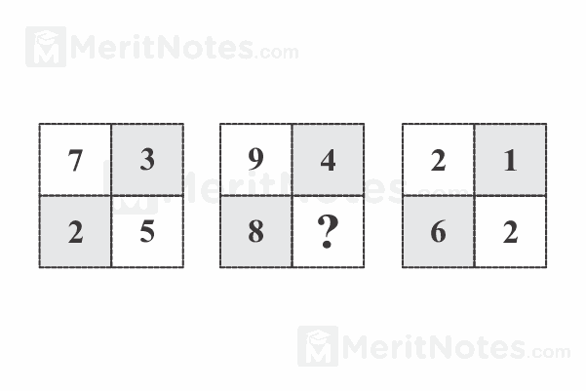

Ans: 7

Numbers in the middle square are the sum of numbers in the same positions in the other two squares. So, 5+ 2 = 7.

**Q56:**



Ans: 61

(7 x 9) - (3 x 4) + 10 = 63 - 2 = 61.

**Q57:**

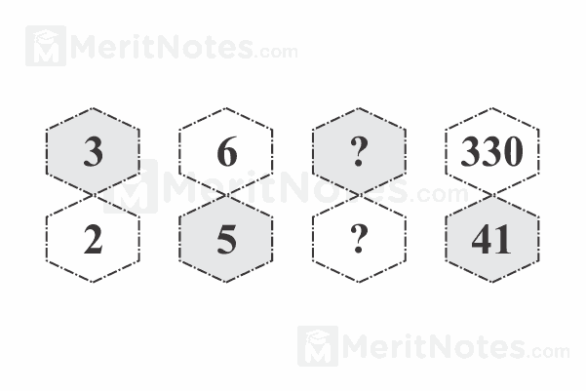

Answer



The top number is the product of the two previous numbers. The bottom number is the sum of the two previous numbers. 30 = 6 x 5; 11 = 6 + 5.

**Q58:**

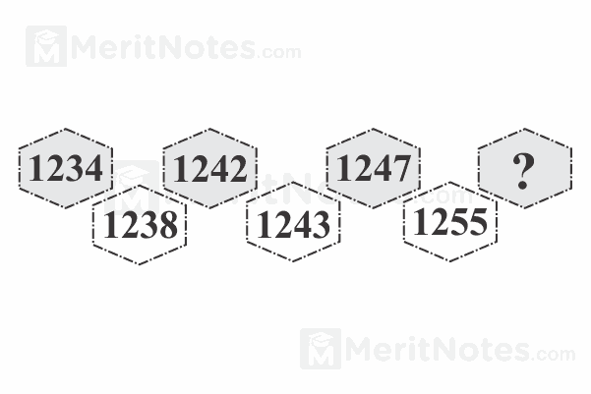Ans:1266.

Each number is the previous number plus the digits in the previous number that are odd. 1266 = 1255 +1 + 5 + 5.

**Q59:**

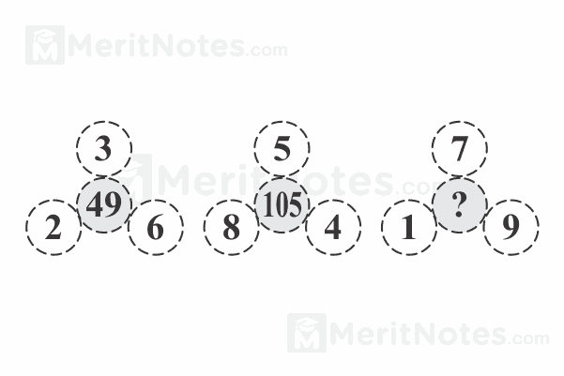

Ans: 131.

The center number is the sum of the squares of the outer numbers.

131 = 12, + 72 + 9 2

**Q60:**

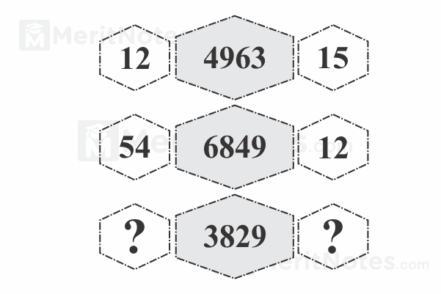

Ans: 27 and 10

3 x 9 = 27 and 8 + 2 = 10.

**Q61:**

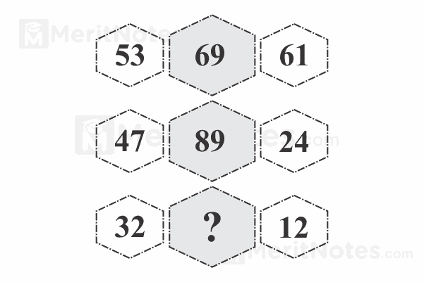

Ans: 53

5 + 1 = 6

3 + 6 = 9

Similarly 4 + 4 = 8

7 + 2 = 89 and

3+ 2 = 5

2 + 1 = 3

**Q62:**

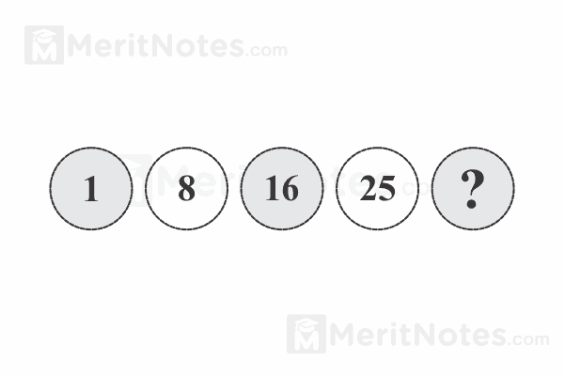

Ans: 35

Numbers advance in steps of 7, 8, 9 and 10.

**Q63:**

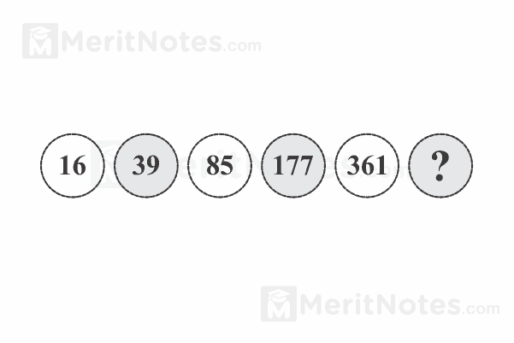

Ans: 729

Each number is doubled and then 7 is added to make the next.

**Q64:**

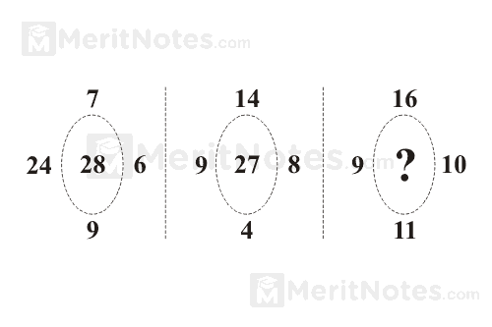

Answer

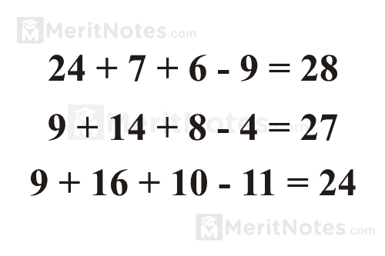

**Q65:**

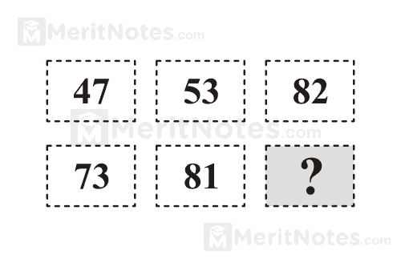

Ans: 91

47 + 35 ( 53 reversed) = 82

73 + 18 (81 reversed) = 91

**Q66:**

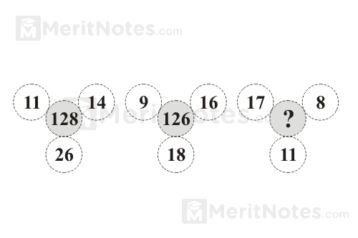

Ans: 125

(11 x 14) - 26 = 128

(9 x 16) - 18 = 126

(17 x 8) - 11 = 125

**Q67:**

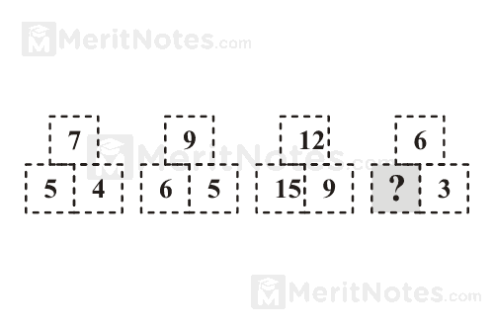

Ans: 3

6 + 3 = 9, 9 ÷ 3 = 3.

Similarly 7 + 5 = 12, 12 ÷ 3 = 4 and

9 + 6 = 15, 15 ÷ 3 = 5

**Q68:**

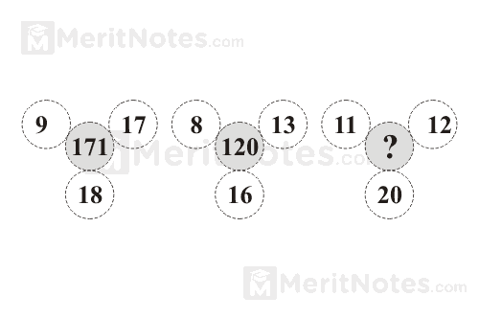

Ans: 152

(9 x 17) + 18 = 171

(8 x 13) + 16 = 120

(11 x 12) + 20 = 152

**Q69:**

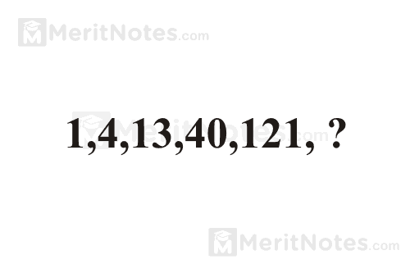

Ans: 364

The sequence is × 3 + 1.

**Q70:**

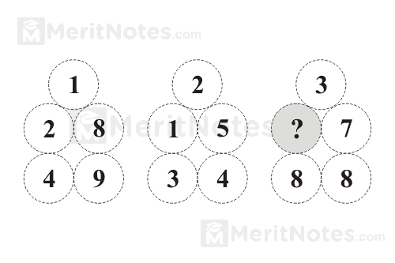

Ans: 2

7 + 8 + 8 = 23.

**Q71:**

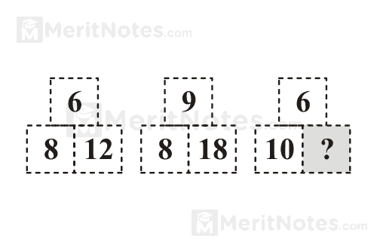

Ans: 15

6 × 10 ÷ 4

**Q72:**

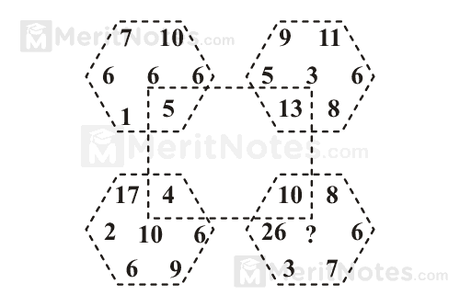

Ans: 5

26 + 3 + 7 + 6 + 8 ÷ 10

**Q73:**

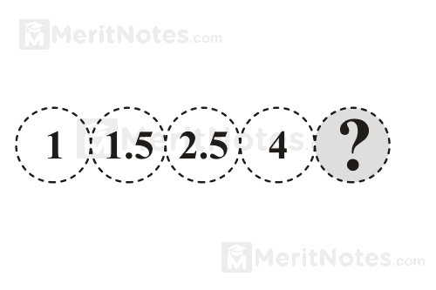

Ans: 6

Add 0.5, 1, 1.5, 2

**Q74:**

**What places the question mark?**

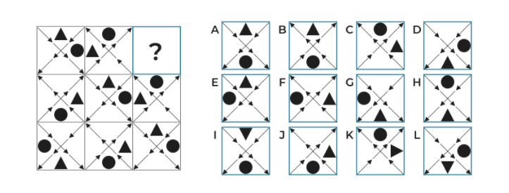

**Ans: G**

**Q75:**

What places the question mark?

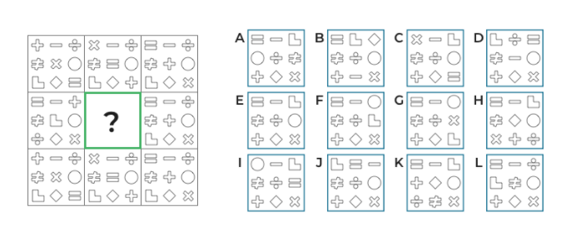

Ans: E

**Q76:**

What places the question mark?

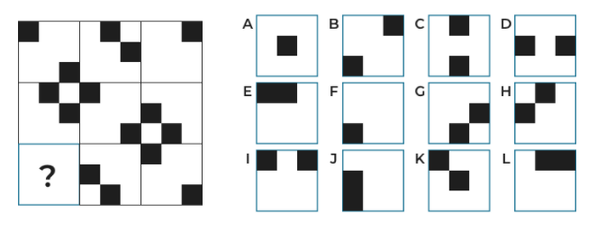

Ans: F

**Q77:**

What places the question mark?

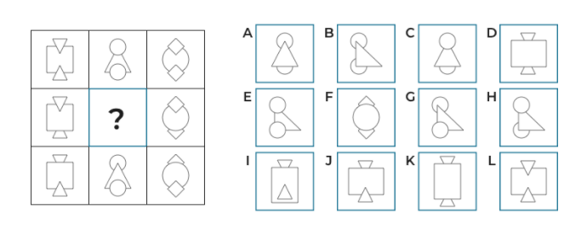

Ans: C

**Q78:**

What places the question mark?

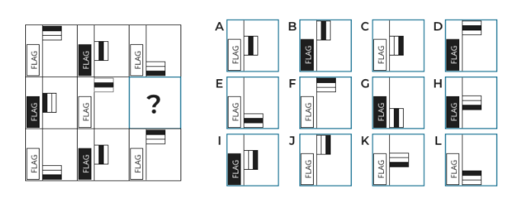

**Ans: I**

**Q79:**

What places the question mark?

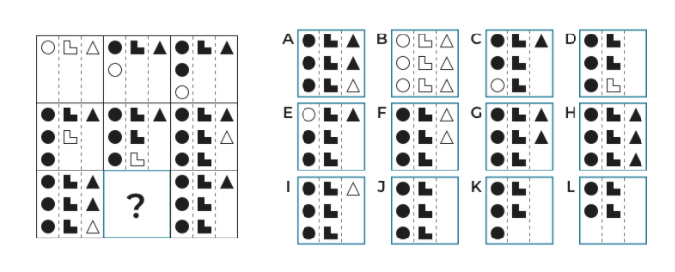

**Ans: G**

**Q80:**

What places the question mark?

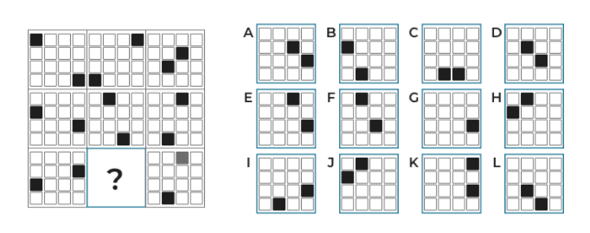

Ans: D

**Q81:**

What places the question mark?

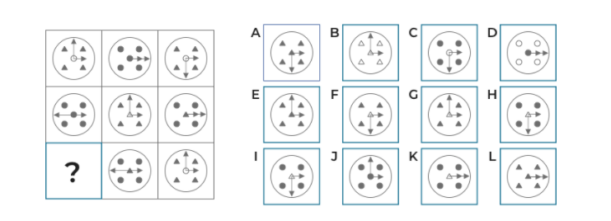

Ans: F

**Q82:**

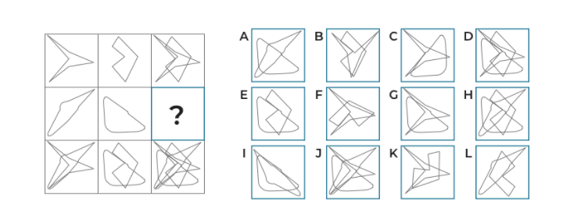

Ans: A

**Q83:**

Description:

Please choose the word which is the exact opposite of the given word:

Word: Nebulous

Answer: Dim, Ambiguous, **Distinct**, Desirable

**Q84:**

Description:

Please choose the word which is the exact opposite of the given word:

Word: Sagacious

Answer: **Foolish,** Incisive, Gnostic, Savvy

**Q85:**

Description:

Please choose the word which is the exact opposite of the given word:

Word: Brittle

Answer: **Flexible**, Friable, Weak, Thin

**Q86:**

Description:

Please choose the word which is the exact opposite of the given word:

Word: Tangible

Answer: Palpable, **Ethereal,** Solid Plain, Plain

**Q87:**

Description:

Please choose the word which is the exact opposite of the given word:

Word: Reticent

Answer: Shallow, Morose, Pessimistic, **Forthcoming**

**Q88:**

Question:

John goes for a jog every third day and every Saturday he goes to the gym. If he goes to the gym and also runs today, how long will it take before there is another day on which he does both?

Answer:

28days, 7days, **21days**, 15days, 5days

**You need to find the smallest common denominator of 3 and 7 which is 21. Thus, after 21days.**

**Q89:**

Question:

Harry buys a garden set from his neighbor. Seeing that he already has a set of his own, he decides to refurbish the one he just bought and resell it. It cost him $64.65 to refurbish the set but unfortunately, he couldn’t succeed in getting a good price for it. He is forced to resell it for $121.50 and in doing so he is left with a loss of $32.15. How much did Harry pay his neighbor for the set in the first place?

Answer:

$64.30, $89.35, $56.85, **$89**, $96.80

It cost Harry $64.65 to refurbish the set. He resold the set for $121.50 meaning that he would have had $121.50 - $64.65 = $56.85 left if the set hadn’t cost him anything. This is not the case, though: Harry led a loss of $32.15. This means that the set cost him $56.85 + $32.15 = $89

**Q90:**

Question:

Johnny can make three payments on his vehicle. The vehicle cost him $19,050. The first installment will be to the value of half this amount. The second installment will be 2/5 of the remaining amount. The rest will be paid with the final installment. How much will Johnny need to pay on his last installment?

Answer:

$4762.50, **$5715**, $2857.50, $3810, $9525

Half of the total amount is 19,050: 2 = 9,525 which means that Johnny will need to pay $9,525 as his first installment. The other half will be paid by 2/5 parts in the second installment. 2/5 of 9,525, thus 9,525 : 5 = 1,905 = 1/5. This means that 2/5 will be 1,905 x 2 = 3,810. This is the amount that Johnny had to pay as his second installment. The final installment will be 9,525 – 3,810 = $5,715.

**Q91:**

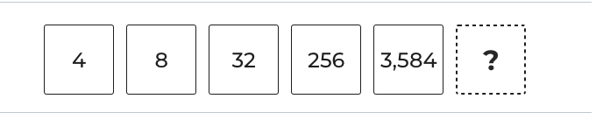

Answer: 68960, 53600, 61440, **78848**, 46080

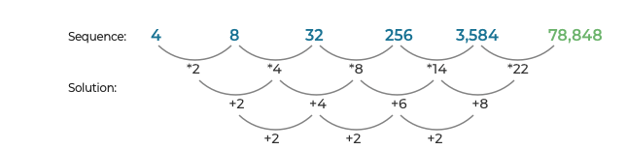

**Q92:**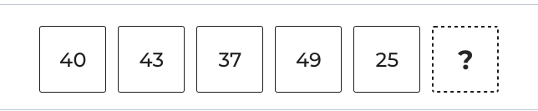

Answer: **73**, -20, -50, 45, -53

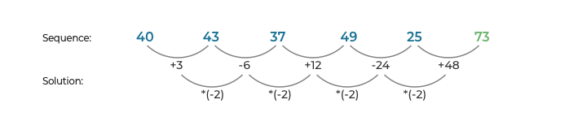

**Q93:**

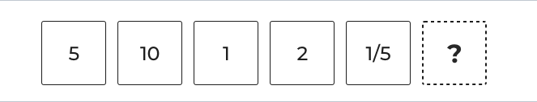

Answer: 4/5, **2/5**, 1/25, 2, 5

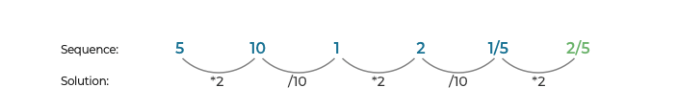

**Q94:**

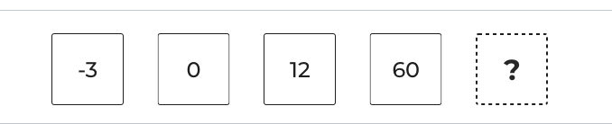

Answer: 120, 180, **252**, 90, 168

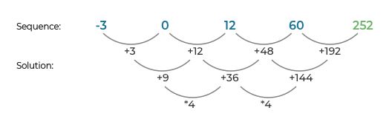

**Q95:**

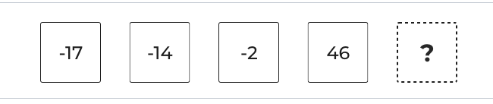

Answer: **238**, 138, 190, 283, 94

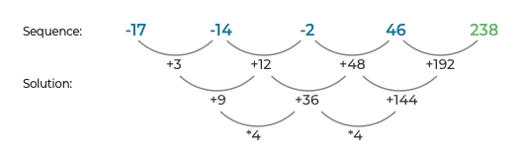

**Q96:**

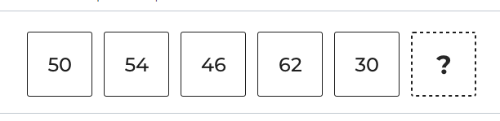

Answer: 82, 92, **94**, 110, 124

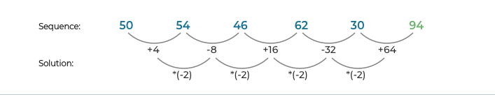

**Q97:**

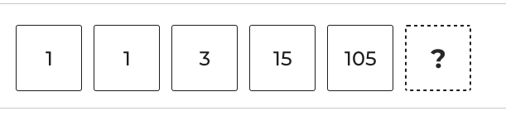

Answer: 950, 845, **945**, 954, 972

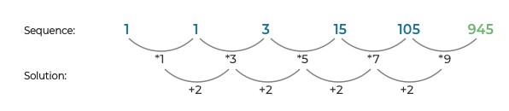

**Q98:**

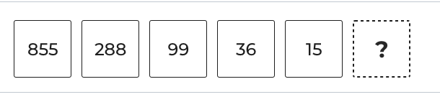

Answer: 5, 6, **8**, 9, 11

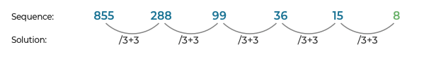

**Q99:**

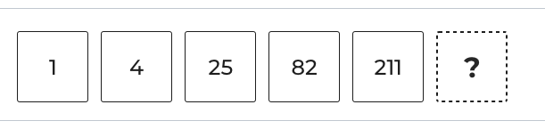

Answer: 482, **484**, 422, 417, 355

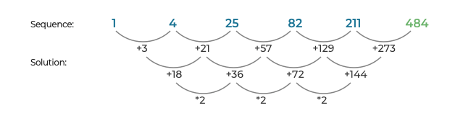

**Q100:**

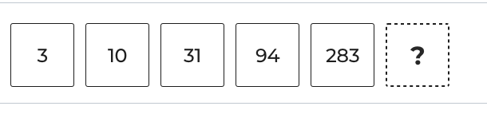

Answer: **850**, 567, 284, 849, 566

